Lab56:
Create a table-valued function to return employees from a specific department with a salary above a certain threshold.
1. create a table valued function:
Create a table-valued function named GetHighEarningEmployees. Which will have parameters as @Department NVARCHAR(50), @MinSalary DECIMAL(10, 2) which will be passed as an input to the function.
@Department NVARCHAR(50)- It specifies the department to filter employees by.
@MinSalary DECIMAL(10, 2)- It specifies the minimum salary threshold for filtering employees.
This function returns a table.
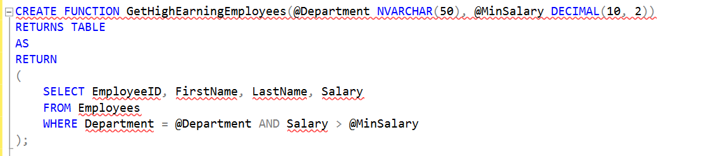

This SELECT statement retrieves columns (EmployeeID, FirstName, LastName, and Salary) from the Employees table where the Department matches the input parameter @Department and the Salary is greater than the input parameter @MinSalary.

2. Use the Table-Valued Function in a Query:

This command calls the GetHighEarningEmployees table-valued function.
IT': This value is passed to the @Department parameter of the function and 70000: This value is passed to the @MinSalary parameter of the function which will retrieves the records of employee table those who have department as an IT and salary greater than 70000.

The output will be:
